How Teleportation Will Work?
Article of the Week #7
Due:____________
Name:
Period:
by Kevin Bonsor and Robert Lamb

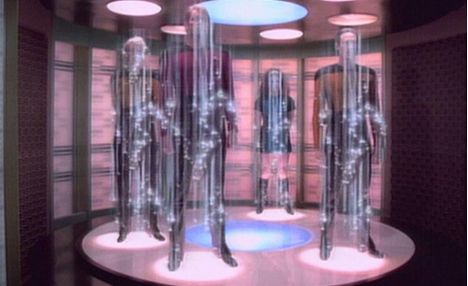
On this side, write a summary for each paragraph.
On this side, write a question or comment for each paragraph.
While you read, circle unfamiliar words and look them up in a dictionary. Then, highlight the most important details.

Sick of those frenzied morning school drop-offs? Longing for a morning commute free of highway road rage and public transit passenger stink?
Well, lucky for you, science is working on an answer, and it might just be as simple as scanning your body down to the subatomic level, annihilating all your favorite parts at point A and then sending all the scanned data to point B, where a computer builds you back up from nothing in a fraction of a second.
Sure, it kind of amounts to chunking your kid in a subatomic wood chipper every morning, but just think of all the time you'll save!
It's called teleportation, and you probably know it best from the likes of "Star Trek" and "The Fly." If realized for humans, this amazing technology would make it possible to travel vast distances without physically crossing the space between. Global transportation will become instantaneous, and interplanetary travel will literally become one small step for man.
Doubtful? Consider for a moment that teleportation hasn't been strictly sci-fi since 1993. That year, the concept moved from the realm of impossible fancy to theoretical reality. Physicist Charles Bennett and a team of IBM researchers confirmed that quantum teleportation was possible, but only if the original object being teleported was destroyed. Why? The act of scanning disrupts the original such that the copy becomes the only surviving original.
This revelation, first announced by Bennett at an annual meeting of the American Physical Society in March 1993, was followed by a report on his findings in the March 29, 1993, issue of Physical Review Letters. Since that time, experiments using photons have proven that quantum teleportation is, in fact, possible.
The work continues today, as researchers combine elements of telecommunications, transportation and quantum physics in astounding ways.
Human Teleportation
Sadly, the transporters of "Star Trek" and the telepods of "The Fly" are not only a far-future possibility, but also perhaps a physical impossibility.
After all, a transporter that enables a person to travel instantaneously to another location might also require that person's information to travel at the speed of light -- and that's a big no-no according to Einstein's theory of special relativity.
Also, for a person to teleport, the teleporter's computer would have to pinpoint and analyze all of the 10²⁸ atoms that make up the human body. That's more than a trillion trillion atoms. This wonder machine would then have to send the information to another location, where another amazing machine would reconstruct the person's body with exact precision.
How much room for error would there be? Forget your fears of splicing DNA with a housefly, because if your molecules reconstituted even a millimeter out of place, you'd "arrive" at your destination with severe neurological or physiological damage.
And the definition of "arrive" would certainly be a point of contention. The transported individual wouldn't actually "arrive" anywhere. The whole process would work far more like a fax machine -- a duplicate of the person would emerge at the receiving end, but what would happen to the original? What do YOU do with your originals after each fax?
It stands to reason, then, that every successful bio-digital teleportation would be an act of murder and creation. Each use would see the digitalization of your body's every detail, the creation of a genetic clone complete with all the travelers' memories, emotions, hopes and dreams.
The original copy would have to die; that is, unless we're cool with the notion of duplicating ourselves every time we need to travel cross-country and committing infanticide each time little Jimmy heads to school.
As with all technologies, scientists will surely continue to improve upon the underlying concepts of teleportation. One day, such a harsh vision of life, death and teleportation may well seem barbaric and uninformed. Our ancestors may feel their bodies fade and dematerialize on one world, even as their eyes open on a planet untold light-years away.

Your Response: Answer the following questions on a s separate sheet of paper. Use complete sentences and restate the question in your answers.
- Do you think teleportation will be possible within your lifetime? Use a quote to support your answer.
- If teleportation were possible today, would you want to use it yourself? Explain why or why not. Use a quote to support your reasoning.
- What are the pros of teleportation? (Why would it be good?) (Use evidence from the text.)
- What are the cons of teleportation? (Why would it be bad?) (Use evidence from the text).

